Computer Architecture Lab
(EL-2012)
LABORATORY REPORT

Fall 2026

(Lab#_02__)
Write Lab Title Here

Student Name: ___Abdulmoeiz_______ Roll No: _______24i-6510_________ Section: __CE A_

Date performed: ____24 August____, 2026

MARKS AWARDED: ________ / 10

Signature and date of Instructor: _________________
Lab Instructors: Dr. Nasir Ali Shah, Engr. Fasih Ahmad

______________________________________________________________________________________________________________________________________________________

NATIONAL UNIVERSITY OF COMPUTER AND EMERGING SCIENCES, ISLAMABAD
Prepared by: | Fasih Ahmad |  | Version: 1.0
Verified by: | Dr. Nasir Ali Shah |  | Updated: Fall 2026

Task 1:

Description:
In this task I designed a Full adder circuit. For this task I built a Half Adder module first and then made another full adder module where 2 Half Adders were made to implement sum and carry operation. Later on, to simulate the circuit a test bench module was made with different combinations of inputs. This task was implemented through both gatelevel and dataflow level.

Code:
module ha(sum, carry, a, b);
input a, b;
output sum, carry;

xor(sum, a, b);
and(carry, a, b);

endmodule

module FA(SUM, Cout, A, B, Cin);
input A, B, Cin;
output SUM, Cout;

wire Sum1, C1, C2;

ha ha1(Sum1, C1, A, B);
ha ha2(SUM, C2, Sum1, Cin);
or(Cout, C1, C2);

endmodule

module FA_testbench;
reg A,B,Cin;
wire SUM, Cout;

FA FA1(SUM,Cout,A,B,Cin);
initial
begin
A = 0; B = 0; Cin = 0;
#10
A = 0; B = 0; Cin = 1;
#10
A = 0; B = 1; Cin = 0;
#10
A = 0; B = 1; Cin = 1;
#10
A = 1; B = 0; Cin = 0;
#10
A = 1; B = 0; Cin = 1;
#10
A = 1; B = 1; Cin = 0;
#10
A = 1; B = 1; Cin = 1;
end
endmodule

DATAFLOW LEVEL MODELLING:

module ha(sum, carry, a, b);
input a, b;
output sum, carry;

assign sum = a^b;
assign carry = a&b;

endmodule

module FA(SUM, Cout, A, B, Cin);
input A, B, Cin;
output SUM, Cout;

wire Sum1, C1, C2;

ha ha1(Sum1, C1, A, B);
ha ha2(SUM, C2, Sum1, Cin);
or(Cout, C1, C2);

endmodule

module FA_testbench;
reg A,B,Cin;
wire SUM, Cout;

FA FA1(SUM,Cout,A,B,Cin);
initial
begin
A = 0; B = 0; Cin = 0;
#10
A = 0; B = 0; Cin = 1;
#10
A = 0; B = 1; Cin = 0;
#10
A = 0; B = 1; Cin = 1;
#10
A = 1; B = 0; Cin = 0;
#10
A = 1; B = 0; Cin = 1;
#10
A = 1; B = 1; Cin = 0;
#10
A = 1; B = 1; Cin = 1;
end
endmodule

LOGISIM CIRCUIT:

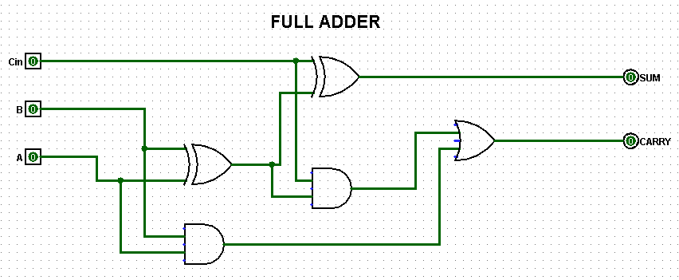

Output:
TESTBENCH WAVEFORMS:

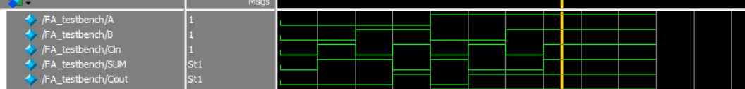

LOGISIM Circuit TruthTable :
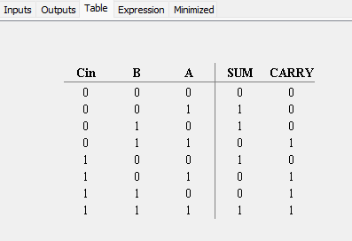

Task 2:

Description:
This task was about designed a 3x8 decoder. This task was required to use multiple input and output variables. Also, we included the “enable” bit as a function as well. The code was implemented in gatelevel and dataflow level and a testbench module was written to test our 3x8 decoder and generate it’s waveforms. The circuit was also deisgned on Logisim to ensure correct working via the TruthTable analysis.

Code:
GATELEVEL MODELLING:

module decoder( a, b,c,en,o0,o1,o2,o3,o4,o5,o6,o7);
input en,a,b,c;
output o0,o1,o2,o3,o4,o5,o6,o7;
wire na,nb, nc;

not(na,a);
not(nb,b);
not(nc,c);

and(o0, en, na, nb, nc);
and(o1, en, na, nb, c);
and(o2, en, na, b, nc);
and(o3, en, na, b, c);
and(o4, en, a, nb, nc);
and(o5, en, a, nb, c);
and(o6, en, a, b, nc);
and(o7, en, a, b, c);

endmodule

module Decode_TB;
reg en,a,b,c;
wire o0,o1,o2,o3,o4,o5,o6,o7;

decoder d1(a,b,c,en,o0,o1,o2,o3,o4,o5,o6,o7);

initial
begin
en = 0; a = 0; b = 0; c = 0;
#10
en = 1; a = 0; b = 0; c = 0;
#10
en = 1; a = 0; b = 0; c = 1;
#10
en = 1; a = 0; b = 1; c = 0;
#10
en = 1; a = 0; b = 1; c = 1;
#10
en = 1; a = 1; b = 0; c = 0;
#10
en = 1; a = 1; b = 0; c = 1;
#10
en = 1; a = 1; b = 1; c = 0;
#10
en = 1; a = 1; b = 1; c = 1;
end
endmodule

DATAFLOW LEVEL MODELLING:

module decoder( a, b,c,en,o0,o1,o2,o3,o4,o5,o6,o7);
input en,a,b,c;
output o0,o1,o2,o3,o4,o5,o6,o7;
wire na,nb, nc;

assign na =~a;
assign nb =~b;
assign nc =~c;

not(nc,c);

assign o0 = na& nb& nc &en;
assign o1 = na& nb& c &en;
assign o2 = na& b& nc &en;
assign o3 = na& b& c &en;
assign o4 = a& nb& nc &en;
assign o5 = a& nb& c &en;
assign o6 = a& b& nc &en;
assign o7 = a& b& c &en;

endmodule

module Decode_TB;
reg en,a,b,c;
wire o0,o1,o2,o3,o4,o5,o6,o7;

decoder d1(a,b,c,en,o0,o1,o2,o3,o4,o5,o6,o7);

initial
begin
en = 0; a = 0; b = 0; c = 0;
#10
en = 1; a = 0; b = 0; c = 0;
#10
en = 1; a = 0; b = 0; c = 1;
#10
en = 1; a = 0; b = 1; c = 0;
#10
en = 1; a = 0; b = 1; c = 1;
#10
en = 1; a = 1; b = 0; c = 0;
#10
en = 1; a = 1; b = 0; c = 1;
#10
en = 1; a = 1; b = 1; c = 0;
#10
en = 1; a = 1; b = 1; c = 1;
end
endmodule

LOGISIM CIRCUIT DESIGN:

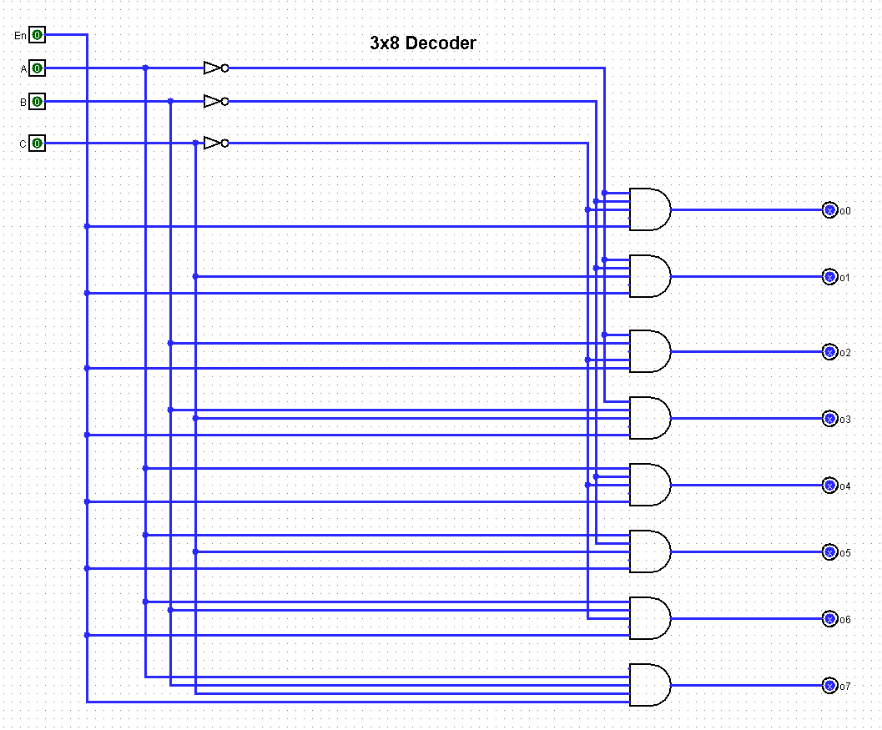

Output:
TESTBENCH WAVEFORM:
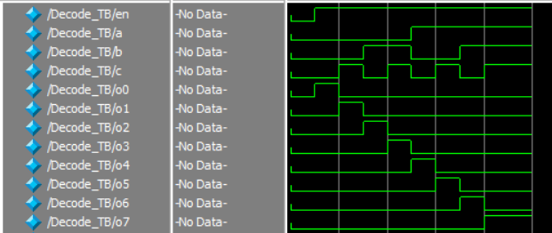
LOGISIM CIRCUIT TRUTHTABLE:
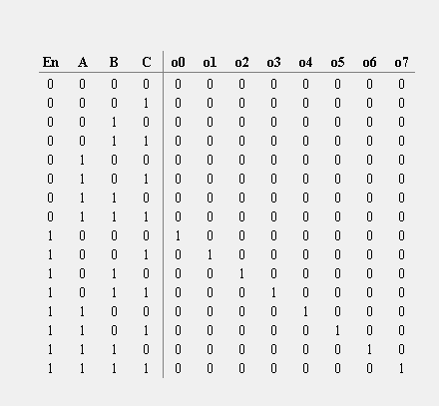

Task 3:

Description:
// Write description of the task here 👇 (max. five to seven lines)

Code:
Output:
// Import output here 👇

Task 2:

Description:
// Write description of the task here 👇 (max. five to seven lines)

Code:
Output:
// Import output here 👇

Task 2:

Description:
// Write description of the task here 👇 (max. five to seven lines)

Code:
Output:
// Import output here 👇

